**Barron’s Let’s Review Regents – Algebra II**

# Chapter 5 Trigonometric Expressions and Equations

## 5.1 Unit Circle Trigonometry

**Key Ideas**

The coordinates of the points on a circle can be described with the sine and cosine of an angle. The ability to describe the location of points on a circle is a skill needed for various real-world applications related to physics.

Finding the Length of the Legs of a Right Triangle with a Unit Hypotenuse

Below is a right triangle ABC with hypotenuse   
unit. Angle C is the right angle, and angle A has a measure of 40 degrees.

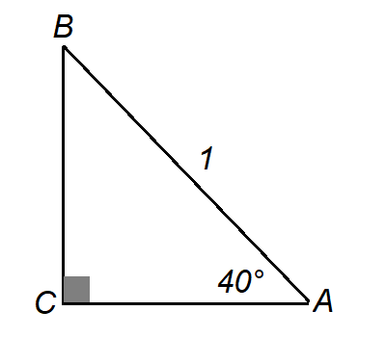

One way to think about sine 40° is that it is the length of the side opposite the 40° angle in a right triangle with a hypotenuse of length 1 unit. If your calculator is in degree monde and you enter sin(40), it should display approximately 0.6428. This means that in triangle ABC, side BC is approximately 0.6428 units long.

If your calculator is not in degree mode, set it to degree mode.

**Example 1**

In the triangle below, what is the length of side BC?

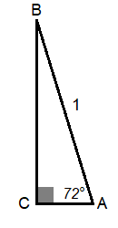

*Solution*: The length of the side opposite the 72 degree angle in a right triangle with hypotenuse 1 is sine 72 degrees, which is approximately 0.9511.

The cosine of an angle can be though of as the length of the side adjacent to the angle in a right triangle that has a hypotenuse of length 1 unit.

In triangle ABC from above, cosine will display the length of side AC, which is adjacent to angle A. (Side AB also seems adjacent to angle A.. Since AB is already the hypotenuse, it can be two things!) If you enter cos(40) on the calculator, it will display approximately 0.7660. If you enter cos(40) on the calculator, it will display approximately 0.7660.

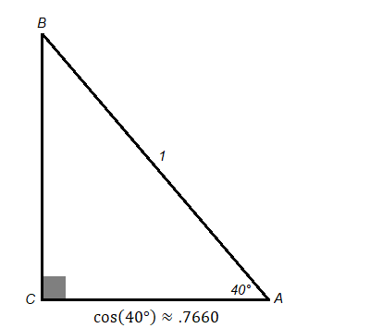

**Math Facts**

In a right triangle with hypotenuse of length 1 unit, the length of a side opposite one of the acute angles is the sine of that angle. The length of a side adjacent to one of the acute angles is the cosine of that angle.

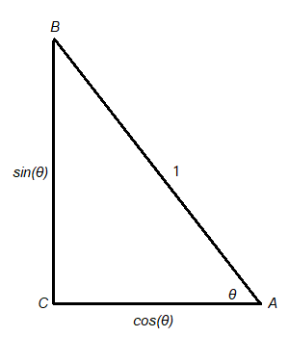

**Example 2**

If AB has length 1 and if angle B has a measure of , find the length of sides AC and BC to the nearest hundredth.

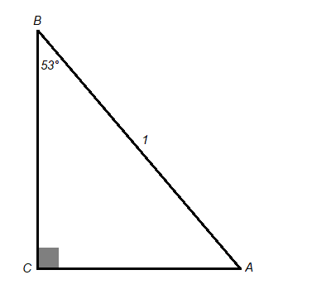

Solution: Since AC is opposite to angle B, its length is sine 53°, which is approximately 0.80. Since BC is adjacent to angle B, its length is cosine 53°, which is approximately 0.60.

In triangle ABC, hypotenuse AB has length 1 and leg BC has length 0.6293. Leg BC is opposite ∠A. So the measure of ∠A can be found by using the calculator to find the angle which has a sine using the function.

Since (make sure you are in degree mode), the measure of angle A is approximately .

**Example 3**

In the triangle below, the length of AB is 1 and the length AC is 0.5446. Rounded to the nearest degree, what is the measure of Angle A?

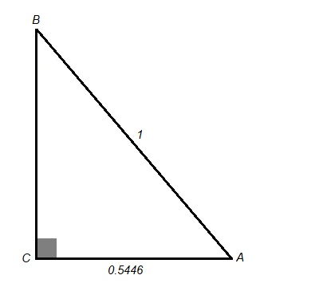

*Solution*: Since AC is adjacent to angle A, the measure of angle A can be found by calculating . Rounded to the nearest degree, the angle is .

Even if the hypotenuse of the right triangle is not 1, cosine and sine can be used to find the lengths of the sides if one of the acute angles is known. In the triangle below, the hypotenuse is 5, angle A is 40 degrees, and the length of side BC is the unknown.

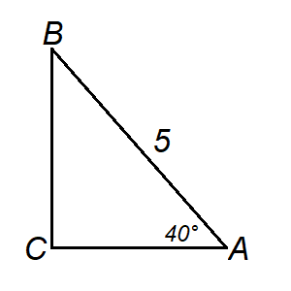

If the hypotenuse were 1, the length of BC would be . Since the hypotenuse is 5 times greater than 1, the side BC will be 5 times greater than 0.6428. Since , this is the length of BC.

**Math Facts**

If the hypotenuse of the triangle has length , the length of the side opposite angle A will be and the length of the side adjacent to angle A will be

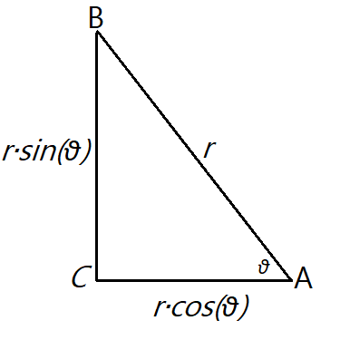

To find an unknown acute angle when one of the legs is unknown and the hypotenuse is not 1, divide the lengths of the known sides by the length of the hypotenuse. This changes the triangle into a similar triangle with hypotenuse 1. The angle can then be solved with (if the adjacent side was known) or with if the opposite side was known.

**Example 4**

The length of AB is 8 and the length of BC is approximately 7.1904. What is the measure of ∠A rounded to the nearest degree?

Solution: When the lengths of sides AB and BC are both divided by 8, which is the length of the hypotenuse, AB becomes 1 and BC becomes 0.8988. Since BC is the side opposite ∠A, the measure of ∠A can be found with . Since is approximately , this is the measure of ∠A.

If in a right triangle only the two legs are known, the Pythagorean theorem can be used to find the hypotenuse first. Then either sine or cosine can be used to find the measure of the angle.

Example 5

The right triangle below has a vertex at (-3, 4). What is the measure of ∠BOP? What is the measure of angle BOP?

Solution: The length of OP can be calculated with the Pythagorean theorem. . So   
. Divide the three sides by 5, and the triangle becomes:

Since ∠AOP is supplementary to ∠BOP,   
.

**Locating Points on the Unit Quarter Circle**

The unit quarter circle is the part of a circle centered at (0, 0) with a radian of 1 and that is in the first quadrant.

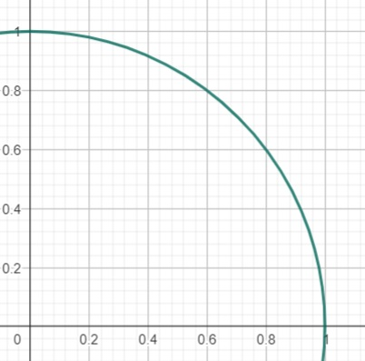

If a radius is drawn so the angle between the radius OP and OA is , it is possible to find the coordinates of the endpoint of the radius P by drawing a line segment PR perpendicular to the -axis.

<https://www.geogebra.org/m/U3HATYTv>

**Example 6**

IN this unit quarter circle, angle AOP is 61°. What are the coordinates of point P.

*Solution*: The coordinates of point P are   
(cosine 61°, sine 61°) (0.48, 0.87)

**Locating Points on the Full Unit Circle**

Even if ∠AOP is greater than , the -coordinate of point P will be the cosine of ∠AOP and the -coordinate will be the sine of ∠AOP.

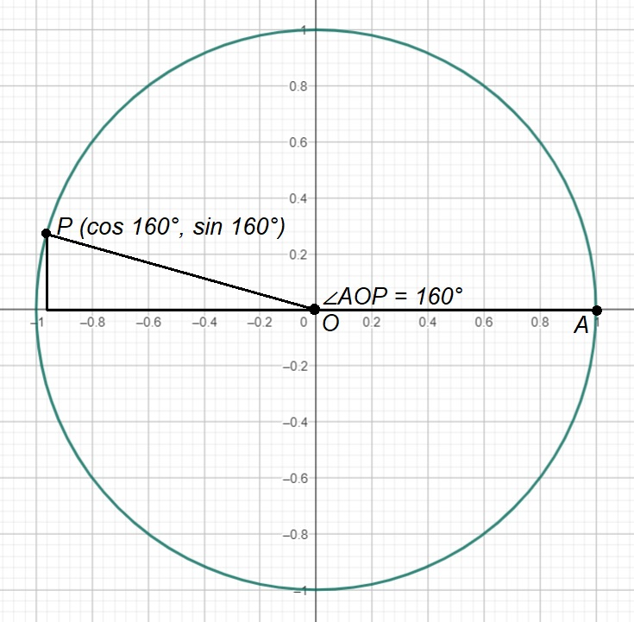

In the unit circle above, ∠AOP is 160°. The coordinates of point P are (cosine , sine ). This can be approximated on the calculator as   
(-0.94, 0.34).

This way of thinking about sine and cosign with a unit circle is related to, but different from, thinking about them with a right triangle.

If you reflect segment OP over the -axis to become , that acute ∠AOP would be . The acute angle you get when you reflect point into quadrant I is known as the *reference angle*.

If ∠AOP is greater than , point “wraps around” and will be in the same location as some other point that is less than . For example, the point at is at the same location as the point   
. This is why the sine of is the same as the sine of .

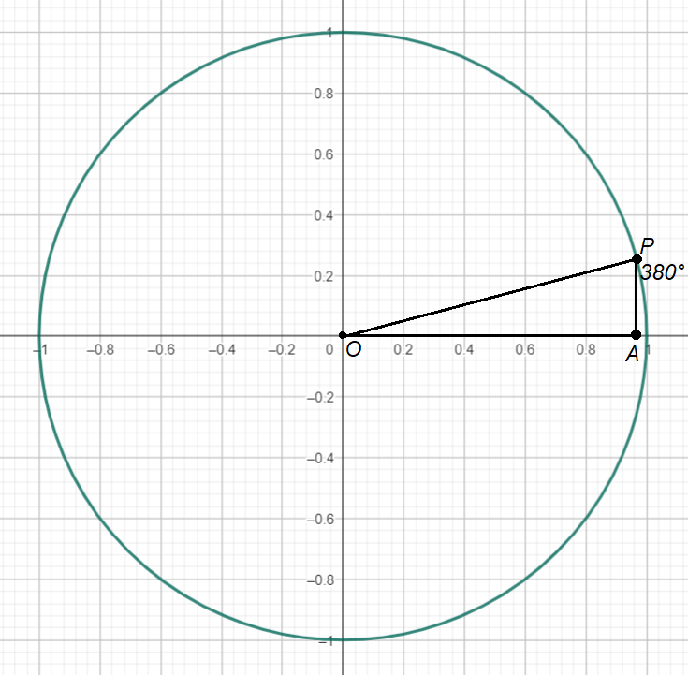

**Math Facts**

If circle is a unit circle centered at (0, 0), point A is located at (1, 0) and point P is on the circle, the coordinates of point P are (cosine ∠AOP, sine ∠AOP). Depending on which quadrant P is in, sine, cosine, or both could be negative.

Example 7

If ∠AOP is between and , what can be inferred about sine ∠AOP and cosine ∠AOP?  
  
(1) They are both positive.  
(2) Sine ∠AOP is positive, but cosine ∠AOP is negative.  
(3) Sine ∠AOP is negative, but cosine ∠AOP is positive.  
(4) They are both negative.

*Solution*: Choice (4) is correct. Every point in the quadrant III, including point P, has a negative   
-coordinate and a negative -coordinate. Since the -coordinate is cosine ∠AOP and since the   
-coordinate is negative, cosine ∠AOP must also be negative. Since the -coordinate is sine ∠AOP and since the -coordindate is negative, sine ∠AOP must also be negative.

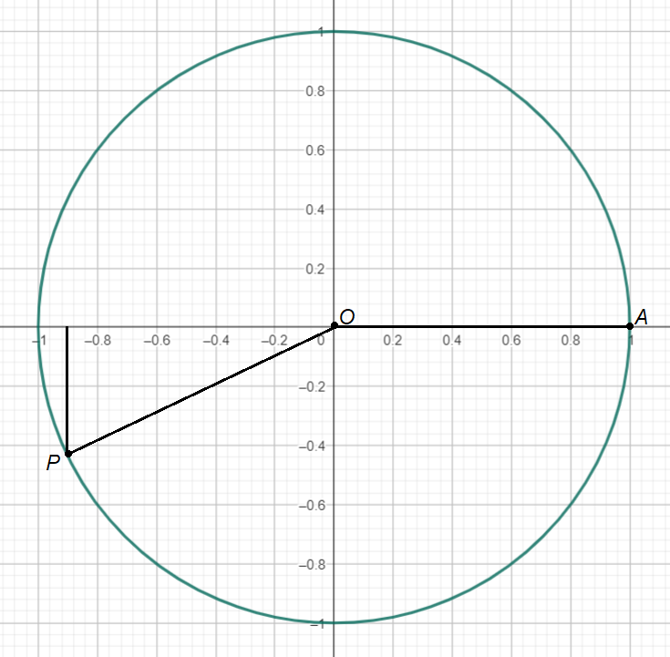

An alternate way to answer this question would be to choose some angle between and , such as . Then enter cos(205) and sin(205) into the calculator (be sure you are in degree mode) to see they are both negative.

**Example 8**

Point P is on the unit circle with point at (1, 0). If the sine of ∠AOP is negative and cosine of ∠AOP is positive, what is true about ∠AOP?

(1) It is between 0° and 90°.  
(2) It is between 90° and 180°.  
(3) It is between 180° and 270°.  
(4) It is between 270° and 360°

*Solution*: On the unit circle, the points that have a positive -coordinate and a negative -coordinate are in quadrant IV. The points on the unit circle in quadrant IV range from 270° to 360°, so the answer is choice (4).

**Example 9**

If sin ∠AOP is negative, in what two quadrants can point P be in?

(1) I or II  
(2) II or III  
(3) III or IV  
(4) I or IV

Solution: Since sine is related to the -coordinate of point P and since points in quadrant III and IV have negative -coordinates, the answer is choice (3).

If the coordinates of point P are known, it is possible to determine the measure of ∠AOP with the graphing calculator. Calculating the angle’s measure does differ a bit depending on what quadrant point is in.

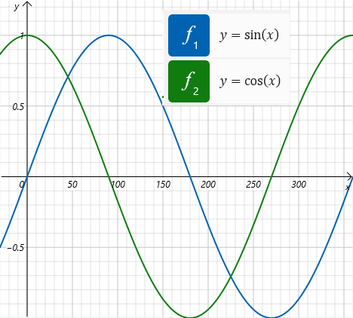

**If point P is in quadrant I:**

**If point P is in quadrant II:**

**If point P is in quadrant III:**

**If point P is in quadrant IV:**

**Example 10**

If point has coordinates (-0.8910, -04540), what is the measure of ∠AOP rounded to the nearest degree?

*Solution*: A sketch of the unit circle shows that the measure of the angle will be between and .

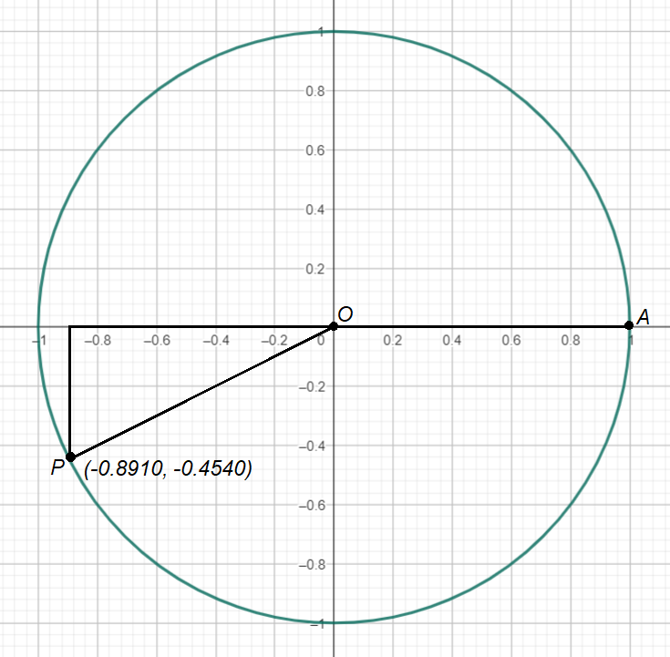

Since point P is in quadrant III, the angle can be calculated with either or . Either way, the answer is .

Notice that with the process described above, you should always put a positive number into the or function, even if the -coordinate or   
-coordinate is negative.

**Example 11**

If sin ∠AOP is 0.6 and cos ∠AOP is negative, what is the value of cos ∠AOP?

*Solution*: Since the sine is positive, point must be in either quadrants I or II. Since cosine is negative, point must be in either quadrant II or III. So, point must be in quadrant II since that is where both sine is positive and cosine is negative.

∠AOP can be calculated with the formula . Then use the calculator to find cosine .

**Example 12**If sin ∠AOP is and cos ∠AOP is positive, what is the value of cos ∠AOP?

(1)   
(2)   
(3)   
(4)

*Solution*: Since the sine is negative, point must be in either quadrants III or IV. Since cosine is positive, point must be in quadrants I or IV. So point must be in quadrant IV since that is where both sine is negative, and cosine is positive.

∠AOP can be calculated with the formula

.

Then use the calculator to get cosine . Of the choices that are positive, , which is very close to 0.9205. The answer is choice (1).

**Example 13**

If the coordinates of A are (-3, 0), of O are (0, 0) and of P are (-3, 4), what is the cosine of ∠AOP?

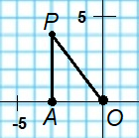

*Solution*: The sine of ∠AOP is the -coordinate of the point of intersection (Q) between the unit circle and the line OP. The length of the sides of triangle AOP are 3, 4 and 5. Since the hypotenuse OP has a length of 5, dividing all sides b 5 will create a triangle with hypotenuse of 1. The lengths of the sides of similar triangle BOQ are Point Q has coordinates

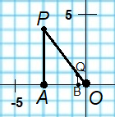

### Check Your Understanding of Section 5.1

1. Multiple-Choice
2. In right triangle ABC, if and , what is the length of BC?  
   **(2)**
3. In right triangle ABC, the measure of ∡A is and What is the length of AC?  
   **(1) 0.9063**
4. In the right triangle DEF, the measure of ∡D is and . What is the length of EF?  
   **(4) 0.7986**
5. In right triangle EFG, if and if , what is the measure of ∡G?  
   **(3)**
6. In unit circle , if , what are the coordinates of ?  
   **(2) (0.34, 0.94)**
7. In unit circle , if , what are the coordinates of B?  
   **(4) (-0.34, 0.94)**
8. If is on the unit circle, the -coordinate of B is positive, and the -coordinate of is negative, in which quadrant is point ?  
   A positive -coordinate implies quadrant I or IV. A negative -coordinate implies quadrants III or IV.   
   **(4) IV**
9. In unit circle , the coordinates of point are (-0.91, -0.41). What is the measure of ?  
     
   **If point P is in quadrant III:  
   (4)**
10. If and and θ is in the standard position, in which quadrant is the terminal ray of θ?  
     implies quadrant I or II.  
     implies quadrant II or III.  
    **(2) II**
11. Point is on unit circle . What are the coordinates of ∠θ?  
    , Diagram for wrong?  
    **No answer in the book agrees with my answer.** Google agrees with my answer. Point B is on unit circle in third quadrant with angle theta. In terms of cos and sin, what are the coordinates of point B.
12. *Show how you arrived at your answers*.
13. Right triangle ABC is similar to triangle DEF.  
    (a) what is the length of AC?  
    By Pythagorean theorem:  
    (b) What is the length of DF?  
    By similar triangles:
14. In right triangle EFG with hypotenuse , what are the lengths of segments and ?  
      
    In a right triangle with hypotenuse of length 1 unit, the length of a side opposite one of the acute angles is the sine of that angle. The length of a side adjacent to one of the acute angles is the cosine of that angle.  
    
15. What is the measure of ∠AOB?  
    Point (-0.8, 0.6)
16. What are three angles between and that have a reference angle of ?  
      
    In trigonometry, a reference angle is the positive acute angle formed between the terminal side of an angle and the x-axis. It's always less than 90 degrees and helps simplify calculations of trigonometric functions for angles outside the first quadrant.   
      
    **Reference Angles**
17. If and , what is the value of   
    A negative sine value indicates quadrant III or quadrant IV, indicating .  
      
    **Quadrant III:**

## 5.2 Trigonometry Equations

**Key Ideas**

A trigonometry equation (often abbreviated as “trig equation”) is one where the variable to be solved for is an angle. Trig equations often have multiple solutions, though it is possible for them to have one or zero solutions.

The equation is an example of a trig equation that has solutiosn between and . If you enter into a calculator it will say 0.5. If you instead, enter it will also say 0.5. So the solution set for this equation is .

**Approximating Solutions to Trig Equations with the Unit Circle**

The unit circle explains why there are generally two answers to trig equations. On the axes below is the unit circle and the horizontal line . The points on the circumference of the circle are 10 degrees apart from one another. As the horizontal line intersects the circle twice, there are two points on the circle that have a -coordinate of 0.5, called and . Also notice that the angle is the same measure as angle , because is a reflection over the -axis of . Angle is a angle, so is 0.5. Angle IS A angle, so sine is also 0.5.

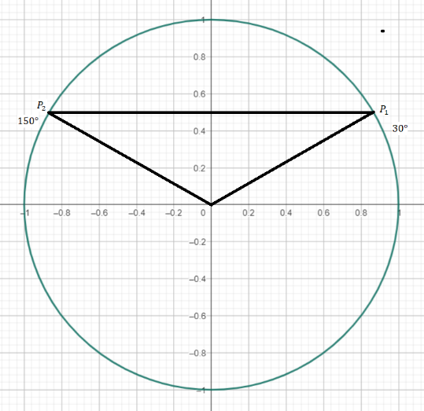

The equation also has two solutions. The line intersects the unit circle at in quadrant III and at in quadrant IV. These points correspond to the angles and , respectively.

To use the unit circle to approximate trig equations involving cosine, a vertical line is needed instead.

**Example 1**

Use the unit circle below to approximate the two solutions (to the nearest ) to the equation .

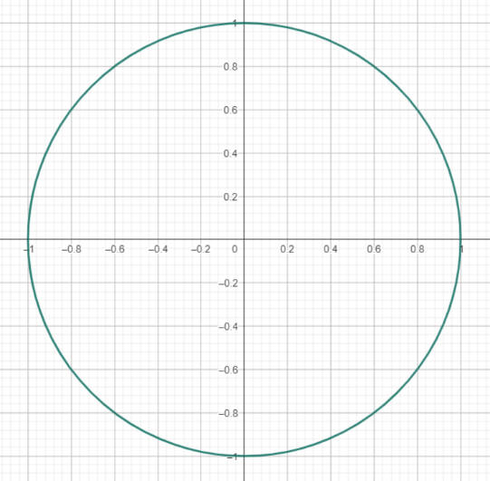

Solution: Points and both should have -coordinates of 0.75 since the -coordinate of a point on the unit circle is the cosine of the angle. Angle is approximately .

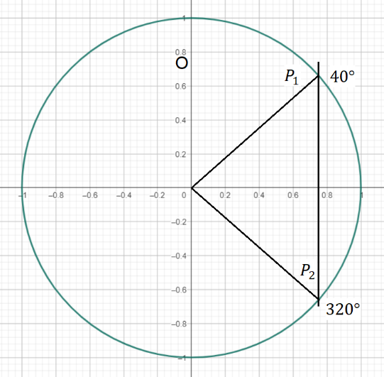

In cases where the vertical or horizontal line does not intersect the circle at all, the trig equation is said to have no solution. If the vertical or horizontal line is tangent to the circle, touching it at just one point, the trig equation has just one solution.

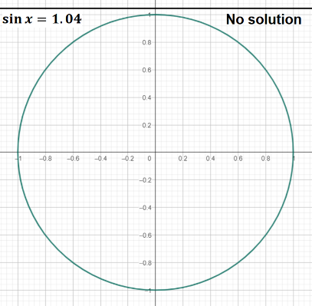

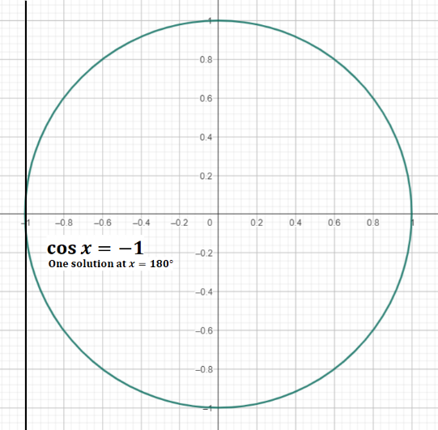

**Solving Trig Equations More Precisely with a Unit Circle and a Calculator**

Finding the two solutions between and to a trig equation like requires four steps.

**Step 1:**

Sketch the proper vertical or horizontal line on the unit circle. For this example, it is a horizontal line at .

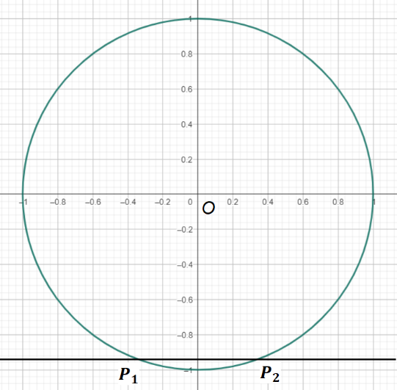

**Step 2:**

Identify the quadrants for any points of intersection between the unit circle and the line from step 1. For this example, point is in the quadrant III and is in the quadrant IV.

**Step 3:**

Determine the reference angle by taking the or the of the absolute value of the number after the equal sign. For this example, the reference angle is .

**Step 4:**

Depending on which quadrants the intersection points are in, use the following formulas.

* If point is in quadrant I, one solution is   
   reference angle.
* If point is in quadrant II, one solution is   
   reference angle.
* If point is in quadrant III, one solution is   
   reference angle.
* If point is in quadrant IV, one solution is   
   reference angle.

For this example, since is in quadrant III and is in quadrant IV, the two solutions are  
 and .

**Example 2**

Use the unit circle below and the calculator to find the two solutions, to the nearest degree, between and to the trig equation .

Solution: The sketch indicates that there are two points on the unit circle that have -coordinates of . is in quadrant II, and is in quadrant III.

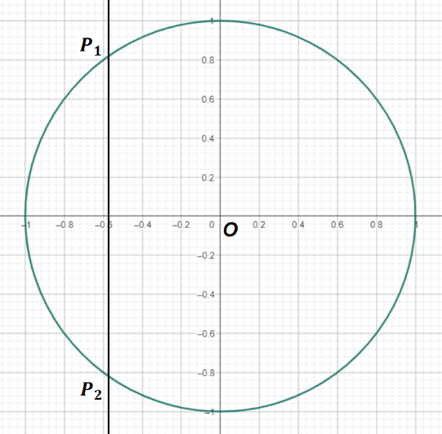

The reference angle is .

The two solutions are and   
.

### Check Your Understanding of Section 5.2

1. Multiple-Choice
2. Based on the unit circle diagram, find the solution(s) to the equation .  
   **(4)**
3. Based on the unit circle diagram, find the solution(s) to the equation .  
   Quadrants: II and III  
   Quadrant II:   
   Quadrant III:   
   **(2) ,**
4. Based on the unit circle diagram, find the solution(s) to the equation   
   **(1)**
5. Find the solution(s) to .  
   Quadrants I and IV.   
   **(4) and**
6. Find the solution(s) to .  
   Quadrants: II and III. .  
   **(4) and**
7. If , what is the maximum number of solutions to the equation where is a real number?  
   **(3) 2 solutions**
8. Find the solution(s) to for   
   .  
   **(4)**
9. At what value(s) of does ?  
   **(3)**
10. If is one solution to where , ?what is another solution?  
    Quadrants I and II.  
    **(1)**
11. What is the solution set for ?  
    **(4) {}**
12. *Show how you arrived at your answers*.
13. On this unit circle, draw the two angles that have a sine of 0.7.  
    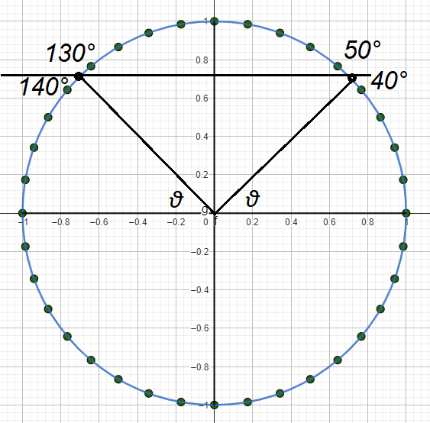
14. On this unit circle, draw the two angles that have a cosine of -0.4.  
    Quadrants: II and III  
    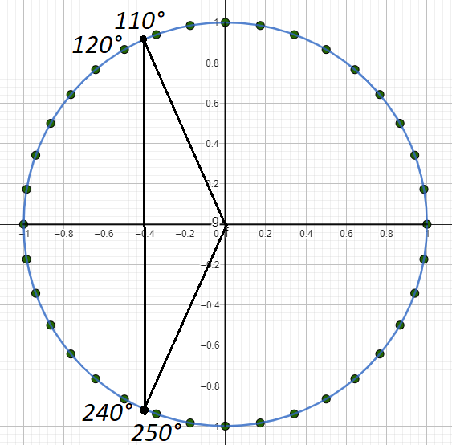
15. How can this unit circle be used to demonstrate that has no solutions?  
      
    Draw a line at . The line does not intersect the circle at all, indicating that has no solutions.
16. What are the two solutions to   
    ?  
    Quadrants III and IV.  
    Quadrant III:  
    Quadrant IV:
17. For which values of , is ?  
    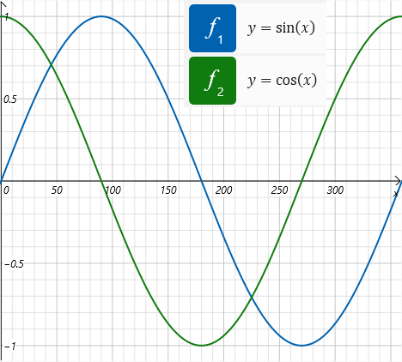

## 5.3 Radian Measure

**Key Ideas**

Just as length can be measured in different units like feet or meters, angles can also be measured in different units. In addition to degrees, angles are sometimes measured in a unit called *radians*. One radian is equal to approximately .

The circumference of the unit circle is   
 units. In the diagram below, the edge of the unit circle is divided into 6 arcs each of length 1 unit and divided into 1 arc of approximately 0.28 units. The 6 larger angles are each 1 radian. Since there are approximately 6.28 radians in a circle, the conversion factor is that 6.28 radians is approximately making the approximate number of degrees in 1 radian .

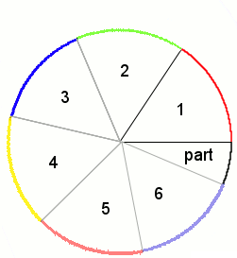

The exact number of radians in a circle is . So the exact number of degrees in 1 radian is .

**Math Facts**

To convert radian measure to degrees, multiply the number of radians by .

**Example 1**

Convert 3.49 radians to degrees, rounded to the nearest degree.

**Example 2**

Convert radians to degrees. Give the exact answer.

**Math Facts**

To convert degrees to radians, divide by . Since dividing by a fraction can be accomplished by multiplying by the reciprocal of that fraction, it is instead quicker to multiply by .

**Example 3**

Convert to radians, rounding to the nearest hundredth of a radian.

*Solution*:

**Example 4**

Convert to radians. Give an exact answer.

*Solution*:

Some common radian to degree conversions are shown in the table.

|  |  |
| --- | --- |
| **Degrees** | **Radians** |
|  |  |
|  |  |
|  |  |
|  |  |
|  |  |
|  |  |

Angles that are multiples of can be found by multipling the radian equivalent of each angle by the appropriate factor.

For example, since , in radians

**Converting Radians and Degrees with a Calculator**

To convert radians to degrees in the Scientific mode of the Windows 10 calculator, first enter the angle in radians. Then, multiply that value by 180 and divide by pi (π). You can find the value of pi by pressing the button that looks like the Greek letter π.

To convert degrees to radians in the scientific calculator mode on Windows 10, you'll need to enter the degree value, press the "pi" button, and then divide by 180. For example, to convert 45 degrees to radians, you would enter "45 * pi / 180".

**Converting Expressions in Terms of to Radians**

When using the calculator to convert degrees to radians, it will give a decimal approximation of the solution itself instead of an exact expression involving . To rewrite as an expression involving , divide the answer by . The quotient will then be the number that goes in front of the in the exact answer.

So is equal to radians.

### Check Your Understanding of Section 5.3

1. *Multiple-Choice*
2. Convert to radians.  
      
   **(3)**
3. Convert to radians.  
      
   **(3)**
4. Convert radians to degrees.  
      
   **(4)**
5. Convert radians to degrees.  
      
   **(3)**
6. Convert to radians, rounded to the nearest hundredth of a radian.  
      
   **(4)**
7. Convert to radians, rounded to the nearest hundredth of a radian.  
      
   **(1)**
8. Convert radians to degrees, rounded to the nearest tenth of a degree.  
      
   **(4)**
9. Convert 2 radians to degrees, rounded to the nearest tenth of a degree.  
      
   **(1)**
10. If circle has a radius of 1 inch and m∡AOB is 1.3 radians, what is the length of arc ?  
    radian = r.  
    **(2) 1.3 inches**
11. In unit circle , if the length of arc is , what are the coordinates of point B?  
    Using radians: Using degrees:   
    Using radians: (0.5, 0.87)  
    Using degrees: (0.5, 0.87)  
       
    **(4)**
12. *Show how you arrived at your answers*.
13. Is 1 radian bigger or smaller than ?  
    Since 1.05 radians > 1 radian,   
    Also: 1 radian =   
    **Since ,**
14. What is ?  
    **Using calculator: -0.8660**
15. Arrange from smallest to biggest: 1 radian, 1 right angle, 1 degree.  
    right angle =   
       
    **1 degree, 1 radian, 1 right angle**
16. In unit circle , if ∡AOB is an acute angle measured in radians, what is bigger: ∡AOB or ?  
    **An acute angle is an angle that measures less than 90 degrees.  
       
       
    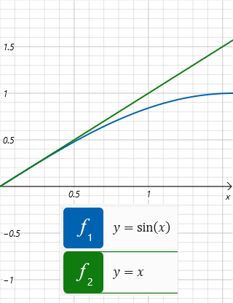  
    0.02 radians,**
17. Some calculators in addition to degrees and radians have a “gradians” mode. A gradian is a unit of angle measurement where 400 gradians are in a circle. How many gradians are in radians?

## 5.4 Graphs of the Sine and Cosine Functions

**Key Ideas**

When a graph is created in which the x-coordinate is the measure of an angle and the y-coordinate is either the sine or the cosine of that angle, the graph has the shape of a wave. This wave shape can be transformed in different ways to make waves that are larger, more compressed, or translated up or down.

**Graphs of the Sine and Cosine Functions**

Each point on the unit circle conveys three pieces of information: the angle AOP, the cosine of ∠AOP (the -coordinate of ), and the sine of ∠AOP (the -coordinate of .

The information from this unit circle can be summarized in a chart.

|  |  |  |  |
| --- | --- | --- | --- |
| **Point** | **Angle** | **Cosine() (-coordinate)** | **Sine() (-coordinate)** |
| *A* |  | 1 | 0 |
| *B* |  | 0.71 | 0.71 |
| *C* |  | 0 | 1 |
| *D* |  | -0.71 | 0.71 |
| *E* |  | -1 | 0 |
| *F* |  | -0.71 | -0.71 |
| *G* |  | 0 | 1 |
| *H* |  | 0.71 | -0.71 |
| *I* |  | 1 | 0 |

To graph the sine function , graph the nine points with the angle measure as the   
-coordinate and the as the -coordinate. The final graph will resemble a backward “S” that is tilted on its side.

To graph the cosine function graph the nine-points with the angle measure as the   
-coordinate and the as the -coordinate. The final graph will resemble a backward “S” that is tilted on its side. In a cosine curve from to , the graph starts at a peak. In contrast to a sine curve, the graph starts at a point in the middle.

If the angle is in radians, the graph will be the same as when the angle is in degrees. However, the scale on the -axis will be different. The end of each cycle will be at instead of at .

**The Amplitude of Sine and Cosine Graphs**

In a function like , the number in front of the trig expression is known as the amplitude. This coefficient transforms the graph with a vertical stretch. The highest point on the graph is now instead of . The lowest point on the graph is now (, -3) instead of .

If the coefficient is negative, there is also a reflection of the curve over the -axis. Here is the graph of .

**Example 1**

Sketch the graph of and   
 on the same set of axes from   
.

*Solution*:

**Example 2**

This is a graph of which equation?

(1)

(2)   
(3)   
(4)

*Solution*: Choice (2) is correct. The graph resembles a cosine curve that has a vertical stretch of factor 4 and is reflected over the -axis. Since this is a multiple-choice question, it could also be answered by graphing each of the four choices to see which graph most resembles the graph in the question.

**Vertical Translations of Sine and Cosine Graphs**

In a function like , the constant term affects the graph. The graph of  
 is like the graph of with each point translated up by 2 units. The invisible horizontal line through the middle of the curve, sometimes called the *axis of the curve*, is also translated up 2 units.

If the constant is negative, the graph will be shifted down.

**Example 3**

Which of the following is the graph of   
?  
  
(1)  
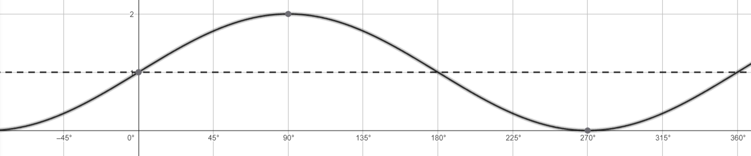

(2)

(3)

(4)

*Solution*: Choice (4) is the answer. It is the graph of shifted down by 1 unit.

**The Frequency of Sine and Cosine Graphs**

The graph of the function is like the graph of but with a horizontal squeeze by a factor of 2. The coefficient of the , the 2 in this example, is known as the frequency since it is the number of complete waves that fit inside a interval.

**Example 4**

Below is the graph of which function?

|  |  |
| --- | --- |
| (1)  (2) | (3)  (4) |

*Solution*: Since 3 cycles of the sine curve fit in a interval, the coefficient of the is 3. Choice (3) is correct.

**The Period of Sine and Cosine Graphs**

The period of a sine or cosine curve is the number of degrees (or radians) needed for the curve to complete one cycle. The period is related to the frequency () by the formula for degrees and for radians.

**Example 5**

What is the period, in degrees, of the curve defined by ?

Solution: Use the formula.

**Math Facts**

When a function is of the form

or

the is the amplitude and affects the vertical stretch of the curve. The is the frequency and affects the horizontal squeeze of the curve. The affects the vertical translation of the curve. The basic curves   
 or have values   
. A function can change one or more of the values to create wavelike curves that pass through different points.

**Graphs of Trig Functions with More than One Transformation**

The graph of the function is like the graph of after four different transformations have been performed on it. The 3 causes a vertical stretch. The negative sign (-) in front of the 3 causes a reflection over the -axis. The 2 causes a horizontal squeeze. The + 1 causes a vertical translation.

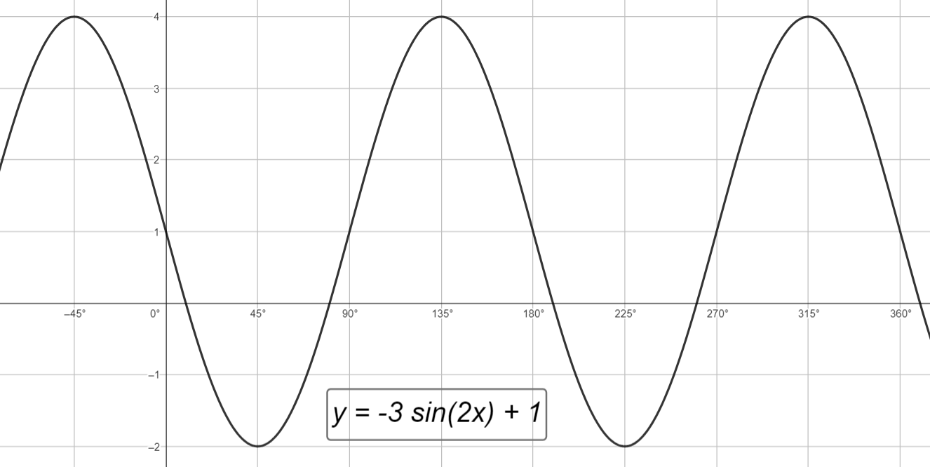

**Example 6**

Which of the following is the graph of   
?

(1)

(2)

(3)

(4)

*Solution*: Choice (2) is the correct answer. It has an amplitude of 2, a frequency of 3, and a vertical shift of 2. It is cosine instead of sine because it starts with a peak instead of in the middle of a curve.

(1)   
(2)   
(3)   
(4) )

**Using a Graphing Calculator to Make a Table of Values**

With a graphing calculator, you can quickly display a graph of a complicated trig function on the screen. However, if the question asks you to reproduce the graph accurately on graph paper, a table of values is useful. The table is best if it contains the entries that correspond to the most important points on the trig graph.

Here are the steps for making a useful table of values for graphing the function on paper.

|  |  |
| --- | --- |
| x | y |
| 0 | 1 |
| 45° | -2 |
| 90° | 1 |
| 135° | 4 |
| 180° | 1 |
| 225° | -2 |
| 270° | 1 |
| 315° | 4 |
| 360° | 1 |

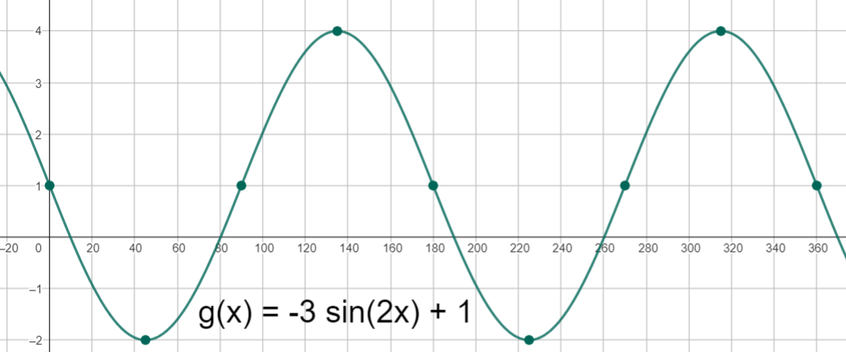

**Finding the Equation of a Function from a Given Graph**

There are five decisions to make when finding the equation of a function on which a trig graph was defined.

1. Is it a sine or a cosine function?
2. What is the vertical shift (the C-value)?
3. What is the amplitude (the A-value)?
4. What is the frequency (the B-value)?
5. Is the coefficient of A positive or negative?

These five questions can be answered in any order.

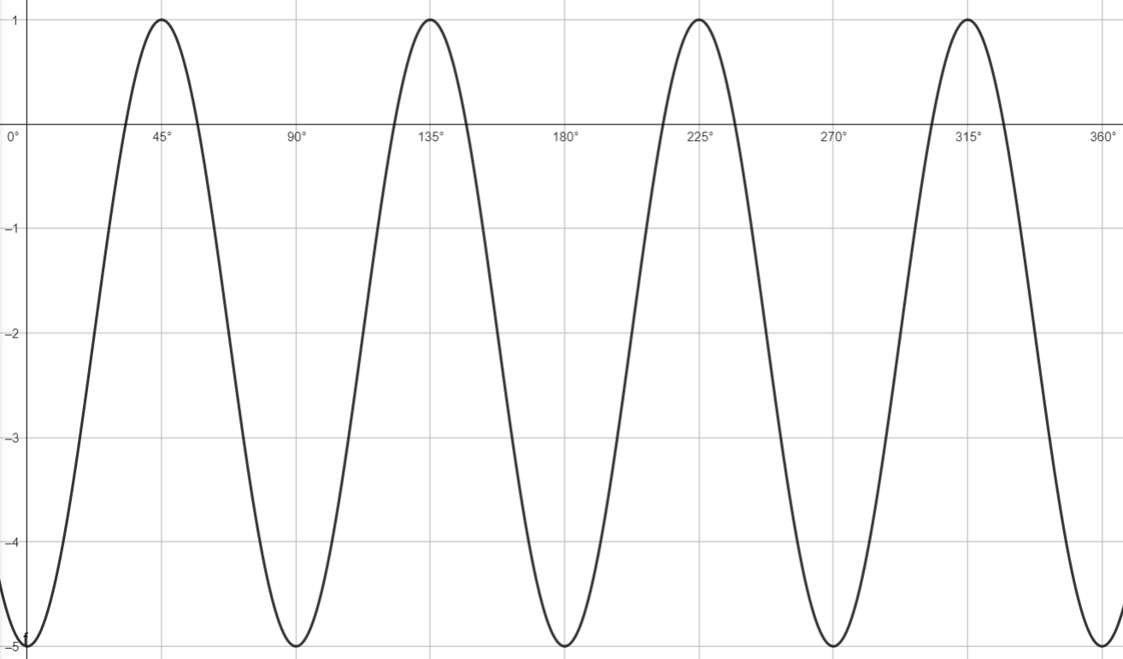

**Step 1:**

Since the y-intercept of this curve is not in the middle of the curve but is at one of the high or low points, this is a cosine curve.

**Step 2:**

Find the value of C, which is the vertical shift. Since the high point is at and the low point is at , halfway between that is , which is the axis of the curve. So .

**Step 3:**

Since the distance from the axis to one of the peaks or low points is 3 units, the amplitude is 3 units, the amplitude is 3. This means .

**Step 4:**

Since the first cycle of this curve ends at the , the period is . The formula that relates period () and frequency () is . So or   
. So .

**Step 5:**

A cosine curve with a negative A value starts from a low point and goes up to the right.

The equation is .

**Example 7**

Below is the graph of which function?

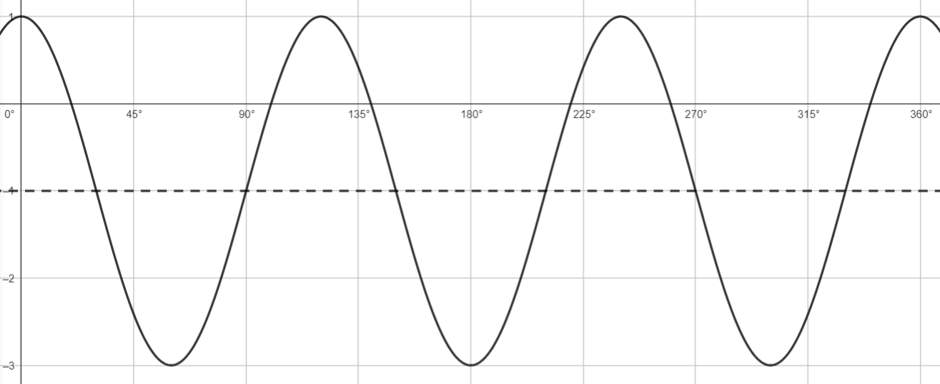

The amplitude A is . The sine curve is not inverted indicating that the coefficient of A is positive, not negative.

There are 3 cycles in , indicating a frequency of .

The axis line of indicates that .

*Solution*:

|  |  |
| --- | --- |
| (1)  (2) | (3)  (4) |

*Solution*: Choice (1) is the correct answer. The amplitude (*A*) is 2. There are 3 (*B*) curves in the interval. Since the axis is at , the curve has a vertical translation of -1 (*C*).

**Example 8**

The angles for this graph are in radians. What is the equation of the function on which this graph is based?

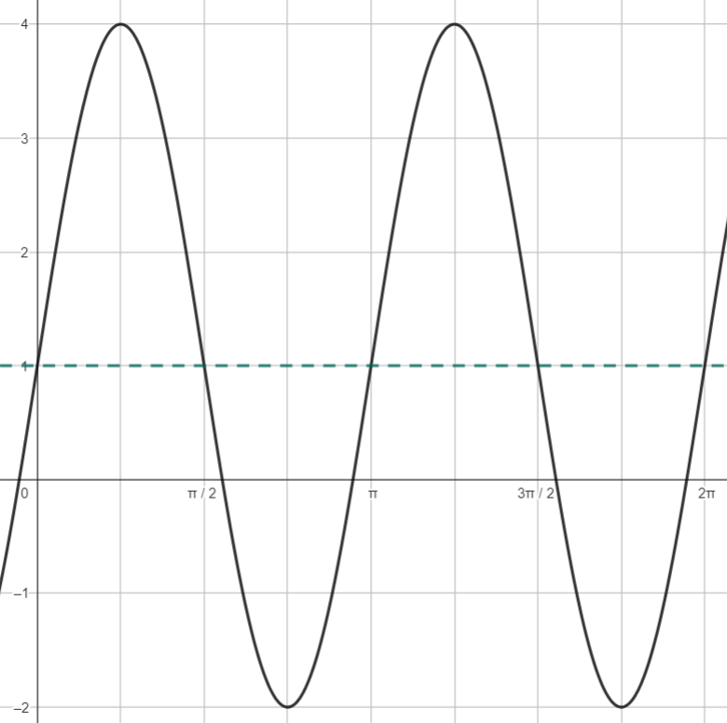

The amplitude (*A*) is .

The frequency (*B*) is 2, because 2 cycles are completed in .

The axis indicates that .

*Solution*: The C-value is 1 since the axis is at . The A-value is +3 since the high point is 3 units above the axis and the sine curve goes up first. To calculate the B-value, solve , with . So .

**Example 9**

If the angles are in radians, find the function on which the following graph is based.

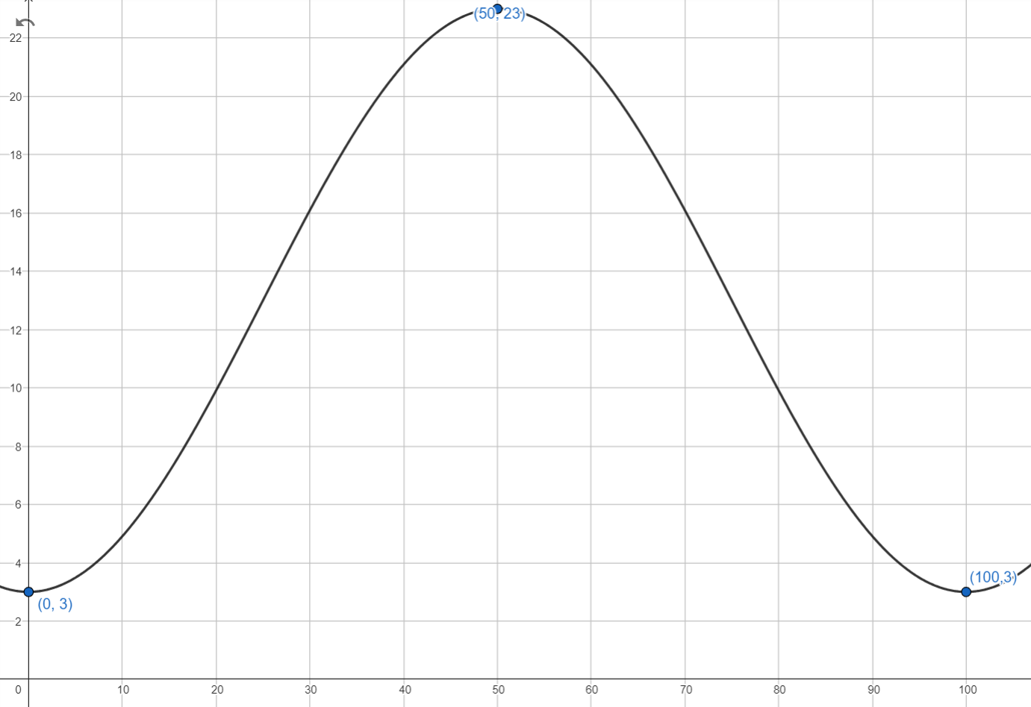

Solution: This is a cosine curve with a negative   
-value. and . The -value can be calculated by . So the equation is